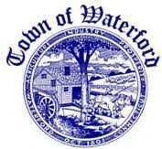
FLOOD AND EROSION CONTROL BOARD
REGULAR MEETING AGENDA
WATERFORD TOWN HALL
MONDAY, JANUARY 26, 2026
6:00 P.M.

- CALL TO ORDER

- NEW BUSINESS

3.OLD BUSINESS

4.PLANS REVIEW

5.CORRESPONDANCE

- PAYMENT OF BILLS

7.APPROVAL OF MINUTES OF NOVEMBER 17, 2025

8.ADJOURNMENT

